**Project Design Phase-I**

**Solution Architecture**

|  |  |
| --- | --- |
| Date | 15 October 2022 |
| Team ID | PNT2022TMID10815 |
| Project Name | Project - Detecting Parkinson’s Disease using Machine Learning |
| Maximum Marks | 4 Marks |

**Solution Architecture:**

Solution architecture is the process of developing solutions based on predefined processes, guidelines and best practices with the objective that the developed solution fits within the enterprise architecture in terms of information architecture, system portfolios, integration requirements and many more.

* Find the best tech solution to solve existing business problems.
* Describe the structure, characteristics, behaviour, and other aspects of the software to project stakeholders.
* Define features, development phases, and solution requirements.
* Provide specifications according to which the solution is defined, managed, and delivered.

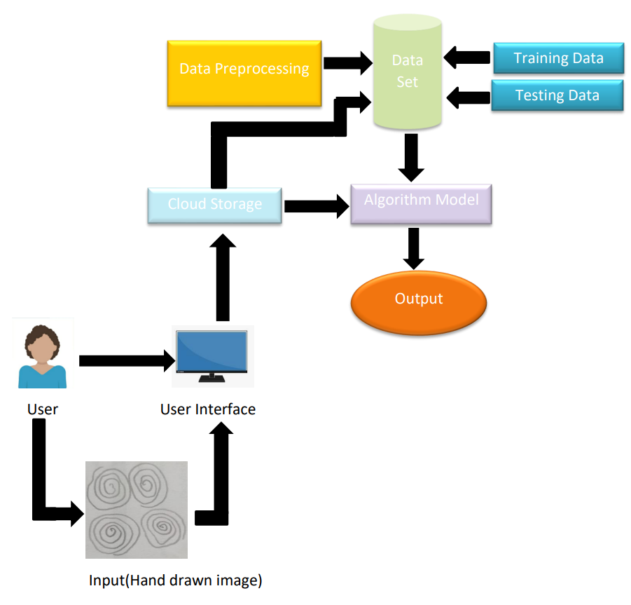**Example - Solution Architecture Diagram:**

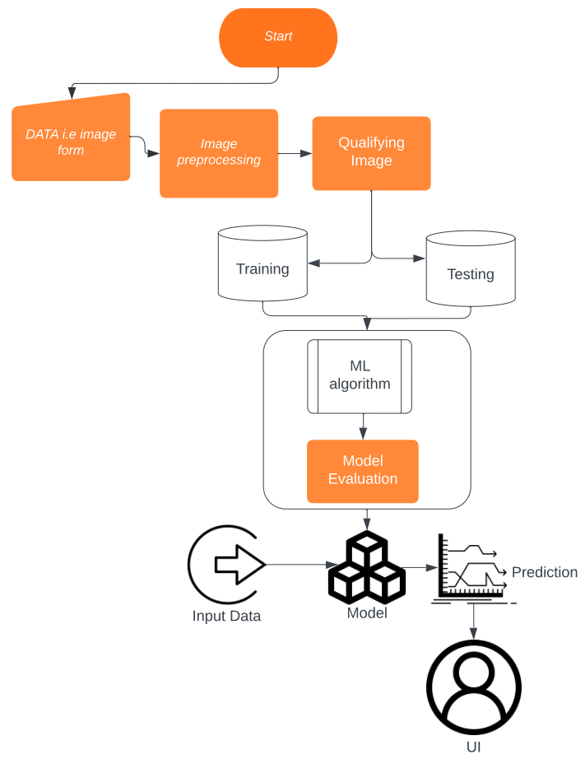

Figure 1: Architecture and data flow of the voice patient diary sample application